TOGAF® Standard – Capability Assessment
Version 1.0
July 2026
Barangay San Antonio Health Department Enterprise Architecture
Barangay San Antonio Health Center, Pasig City
Document Version History
Version  Number | Version  Date | Revised By | Description | Filename
1.0 | October 22, 2026 | UA&P Solution Architecture team | First issue, based on interviews (October 2–21, 2026) and verification answers (October 22, 2026) | A3 - Capability Assessment.docx

Contents
1. Purpose of this Document 5
1.1 Output and Input 5
2. Business Capability Assessment 6
2.1 Capabilities of the Business 6
2.2 Baseline Performance Assessment 7
2.3 Future Performance Aspiration 7
2.4 Baseline Capability Assessment 7
2.5 Future Capability Assessment 8
2.6 Impacts to the Business Organization 8
3. IT Capability Assessment 9
3.1 Baseline Maturity Level of Change Process 9
3.2 Target Maturity Level of Change Process 9
3.3 Baseline Maturity Level of Operational Processes 9
3.4 Target Maturity Level of Operational Processes 9
3.5 Baseline Capability 9
3.6 Capacity Assessment 9
3.7 Impacts to the IT Organization 9
4. Architecture Maturity Assessment 10
4.1 Architecture Governance Processes 10
4.2 Organization, Roles, and Responsibilities 10
4.3 Architecture Skills Assessment 10
4.4 Landscape Definition 10
4.5 Standards Definition 10
4.6 Reference Model Definition 11
4.7 Assessment of Re-Use Potential 11
5. Business Transformation Readiness Assessment 12
5.1 Readiness Factors 12
5.2 Vision for Each Readiness Factor 12
5.3 Current Readiness Ratings 12
5.4 Target Readiness Ratings 12
5.5 Readiness Risks 12
A Abbreviations 14
Tracking Information
Project Name | Barangay San Antonio Health Department Enterprise Architecture
Prepared By | Rome Victor Mag-iba Sendin (Group Leader); Samuel Anthonius Badillo; Wilson Halim; Kevin Enrico Ang | Document Version No. | 1.0
Title | Capability Assessment | Document Version Date | October 22, 2026
Reviewed By | Dr. Glynnis Lynn U. Bonilla, Medical Officer IV (Executive Sponsor) | Review Date | October 23, 2026
Distribution List
From | Date | Phone/Email
Rome Victor Mag-iba Sendin, Group Leader, UA&P Solution Architecture | October 22, 2026 | romevictor.sendin@uap.asia / 09456315746

To | Action* | Due Date | Phone//Email
Dr. Glynnis Lynn U. Bonilla, Medical Officer IV | Approve | October 23, 2026 | bsahealthcenter@gmail.com
Hon. Thomas Raymond U. Lising, Punong Barangay | Review | October 23, 2026 | bsahealthcenter@gmail.com
Hon. Rachel Marie S. Rustia-Olarte, Co-Chair, Committee on Health & Nutrition | Review | October 23, 2026 | bsahealthcenter@gmail.com
Mr. Joel Pira, Instructor, Solution Architecture (UA&P) | Review | October 23, 2026 | joel.pira@uap.asia
* Action Types: Approve, Review, Inform, File, Action Required, Attend Meeting, Other (please specify)

Purpose of this Document
Before embarking upon a detailed Architecture Definition, it is valuable to understand the baseline and target capability level of the enterprise. This Capability Assessment can be examined on several levels:
- What is the capability level of the enterprise as a whole?
Where does the enterprise wish to increase or optimize capability? What are the architectural focus areas that will support the desired development of the enterprise?
- What is the capability or maturity level of the IT function within the enterprise?
What are the likely implications of conducting the architecture project in terms of design governance, operational governance, skills, and organization structure? What is an appropriate style, level of formality, and amount of detail for the architecture project to fit with the culture and capability of the IT organization?
- What is the capability and maturity of the architecture function within the enterprise?
What architectural assets are currently in existence? Are they maintained and accurate? What standards and reference models need to be considered? Are there likely to be opportunities to create re-usable assets during the architecture project?
- Where capability gaps exist, to what extent is the business ready to transform in order to reach the target capability?
What are the risks to transformation, cultural barriers, and other considerations to be addressed beyond the basic capability gap?

Output and Input
The TOGAF® Content Framework (see Architecture Deliverables) identifies deliverables that are produced as outputs from executing the Architecture Development Method (ADM) cycle and potentially consumed as inputs at other points in the ADM.
This deliverable is produced, updated, and consumed by the ADM Phases:
Deliverable | Output from… | Input to…
Capability Assessment | A, E | B, C, D, E, F

Business Capability Assessment

Capabilities of the Business
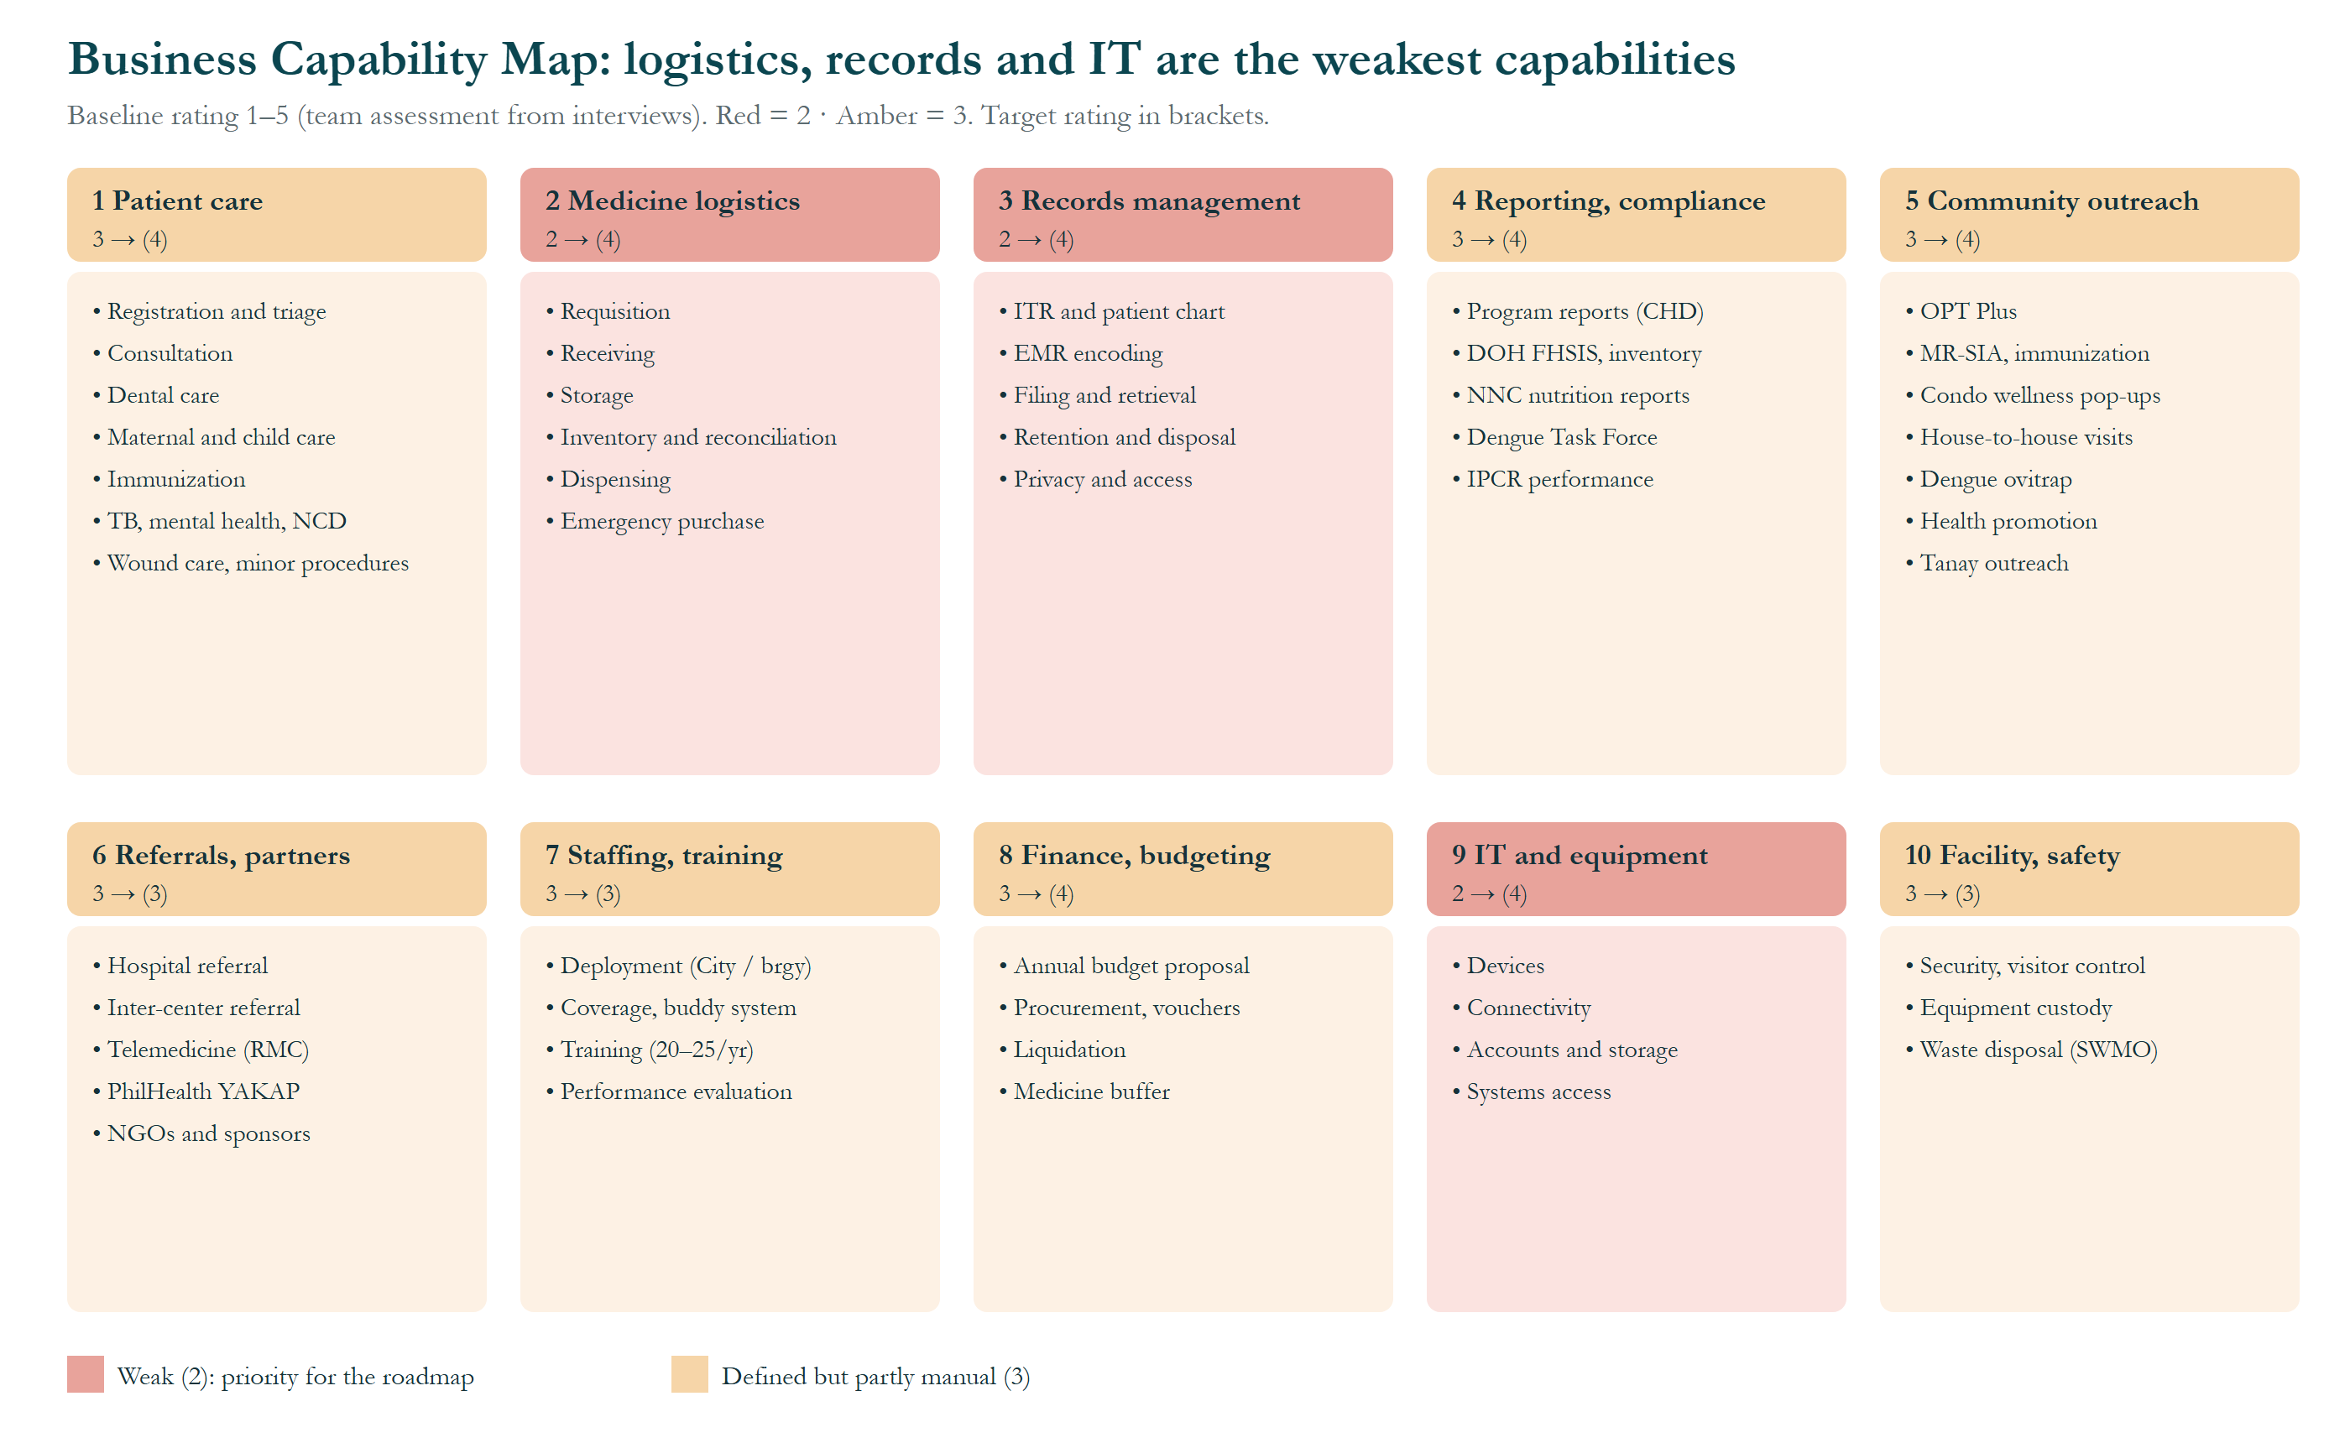
Figure 1. Business Capability Map.
How to read it: each of the ten boxes is a level-1 capability; the bullets inside are the abilities it contains. The rating shows baseline → (target) on a 1–5 scale, assessed by the team from the interviews. Red = 2 (weak), amber = 3 (defined but partly manual).
- Weakest (2 → 4): medicine logistics (no stock alerts, partial deliveries), records management (~8,000 mixed charts, misfiling) and IT and equipment (10-year-old laptops, no frontline computers, personal accounts).
- Working but manual (3 → 4): patient care, reporting and compliance, community outreach, finance and budgeting.
- No change planned (3 → 3): referrals, staffing and training, facility and safety; these work adequately or are controlled by the City.
- Takeaway: the ratings set the roadmap priority: WP1 for logistics, WP4 for records, WP2, WP3 and WP7 for IT.
# | Capability | Description
1 | Patient care | Consultation, dental, prenatal, immunization, family planning, TB, mental health, wound care
2 | Medicine and supply logistics | Request, receive, store, reconcile and dispense medicines and supplies
3 | Records management | ITR, patient charts, EMR encoding, retention and disposal
4 | Reporting and compliance | Program reports to CHD, DOH and NNC; IPCR
5 | Community outreach | OPT Plus, MR-SIA, condo wellness pop-ups, house-to-house visits, dengue ovitraps, Tanay
6 | Referrals and partnerships | Hospitals, other health centers, Rizal Medical Center telemedicine, PhilHealth YAKAP
7 | Staffing and training | City and barangay deployment, buddy system, 20–25 trainings a year
8 | Finance and budgeting | Barangay health and nutrition budget, procurement, liquidation
9 | IT and equipment | Laptops, internet, systems access
10 | Facility and safety | Security, equipment custody, waste disposal

Baseline Performance Assessment
Measure | Baseline | Source
Patient visits | 657 last month (360 consultations + 297 medicine pickups) | Health center verification, Oct 22
Maintenance-medicine patients | About 200–300 a month | Nurse Hardman
Referrals | About 30 a month | Nurse Hardman
Target achievement | 80–90% of own caseload; pregnancies 60–70 of 181 | Dr. Bonilla; Ms. Abong
Record retrieval | 2–3 minutes filed; up to 10 minutes misfiled; about 5 seconds in the EMR | Ms. Abong
Medicine supply | Three months without delivery; about ₱150,000 barangay-funded in 2026 | Ms. Abong; verification
Internet | About 5 outages a month | Dr. Bonilla
Late reports | None to date (late reports lower IPCR ratings) | Ms. Abong

Future Performance Aspiration
- No maintenance-medicine stock-outs.
- Each service entered once at the point of care.
- Old-patient records found in under a minute.
- Monthly reports compiled within working hours and submitted digitally.
- Higher coverage of condo residents and Tanay families.

Baseline Capability Assessment
Rating scale (team assessment from interviews): 1 Ad hoc · 2 Basic, mostly manual · 3 Defined but partly manual · 4 Managed and digital · 5 Optimized.
Capability | Baseline | Basis
Patient care | 3 | Defined clinical flow; no queuing; paper and EMR in parallel
Medicine and supply logistics | 2 | Manual utilization logs; partial deliveries; no alerts
Records management | 2 | ~8,000 charts mixed active/inactive; misfiling; EMR depends on internet
Reporting and compliance | 3 | Always on time, but by manual compilation and hard copies
Community outreach | 3 | Well organized; condo access limited
Referrals and partnerships | 3 | Clear routes; paper-based
Staffing and training | 3 | Frequent training; thin clinical staffing
Finance and budgeting | 3 | Approved budgets; manual ledger; no medicine buffer policy
IT and equipment | 2 | Old laptops; no computers for aides and BHWs; personal accounts
Facility and safety | 3 | Custodian and security in place; LGU waste pickup twice a month; records room partly secured

Future Capability Assessment
Capability | Target | What changes
Medicine and supply logistics | 4 | Digital stock tracker, reorder levels, barangay buffer budget
Records management | 4 | Active-chart index, archived inactive charts, EMR first
Reporting and compliance | 4 | Single data capture; digital submission
IT and equipment | 4 | Shared computers, backup internet, official workspace
Patient care | 4 | Patient queue; less double encoding
Other capabilities | 3–4 | Incremental improvements

Impacts to the Business Organization
- Clinical staff regain time from paperwork; an encoding support role may be needed.
- Aides and BHWs take on simple digital entry once equipped and trained.
- The Committee on Health gains a standing medicine buffer line in the annual budget.
- Paper remains as fallback during outages.

IT Capability Assessment

Baseline Maturity Level of Change Process
Level 2. System changes are decided by the City and its vendor; the EMR was introduced (around 2023) without consulting dentists and updated afterward. The center learns new systems through City seminars.

Target Maturity Level of Change Process
Level 3. The center records change requests, consults users before adopting tools, and sends formal requests to the City Health Department.

Baseline Maturity Level of Operational Processes
Level 2. Daily operations rely on manual logs, personal chats and one encoder; there is no backup connection.

Target Maturity Level of Operational Processes
Level 3–4. Official workspace, digital stock and report tracking, backup internet and documented fallback procedures.

Baseline Capability
Area | Baseline
Applications | City EMR (eMed), dental eMED, PhilHealth HCI/YAKAP, LMIS, ITIS, NNC e-OPT Plus, Google Drive, Messenger/Viber
Devices | 4 City laptops (10+ years old), 2 barangay desktops, 1 barangay laptop, BNS barangay laptop, 4 printers (1 faulty), 1 phone
Connectivity | PLDT line paid by the barangay (~₱3,000 a month for the health center); LGU connection weak or unpaid
Support | One IT officer/encoder; barangay IT team; City vendor for the EMR

Capacity Assessment
The encoder handles EMR, PhilHealth and LMIS entries for all programs; the nurse does not use the EMR because of workload. Aides and BHWs (digital skills about 2/5, per Dr. Bonilla) have no devices. Capacity is the main constraint on further digital work.

Impacts to the IT Organization
- More devices and accounts to manage; the barangay IT team supports the center.
- Simple, documented procedures and basic training are needed.
- Formal coordination with the City for any EMR-related change.

Architecture Maturity Assessment

Architecture Governance Processes
No formal architecture governance exists at the center. Proposed: a small change board (Dr. Bonilla, Kagawad Rustia, Nurse Hardman) applying this project's principles; minor changes to the City Health Officer and major ones to the City Mayor.

Organization, Roles, and Responsibilities
Role | No. | Employer / status | Name(s)
Medical Officer IV (Rural Health Physician) | 1 | City; permanent | Dr. Glynnis Lynn U. Bonilla
Rural Health Dentist | 1 | City; permanent (Tue–Thu here; Mon/Fri at Oranbo) | Dr. Joseph P. Magpali, DMD
Rural Health Nurse | 1 | City; permanent | Ms. Nita N. Hardman, RN
Rural Health Midwife | 1 | City; permanent | Ms. Mafe B. Abong, RM
Nutritionist-Dietitian (Nutrition Officer II) | 1 | City; permanent (Tue–Thu here) | Mr. Christian Jay G. Vasquez, RND
Barangay Nutrition Scholar | 1 | City; permanent since about 2021 | Ms. Mary Anne M. Verches
IT Officer / Medical Encoder | 1 | City; permanent | Mr. Tito F. Reyes
Pasig Health Aide | 4 | City; job order (paid and hired by CHD) | Ms. Janneth D. Correa (OIC), Ms. Rowena A. Intalan, Ms. Rosemarie T. Labandero, Ms. Procelyn L. Tatoy
Barangay Health Worker | 3 | Barangay; contractual (paid and hired by the barangay) | Ms. Joan Marie E. Barcenas, Mr. Perfecto S. Pestaño Jr., Ms. Josefina G. Roa (equipment custodian)
Security Officer | 1 | Barangay | Mr. Jeson C. Medez
Utility | 1 | Barangay | Ms. Vilma D. Lendio

Architecture Skills Assessment
Clinical staff and the encoder rate about 5/5 in digital skills; aides and BHWs about 2/5 (OIC aide about 3–4/5). No architecture skills are in house; the UA&P team provides them for this project.

Landscape Definition
Defined for the first time by this project (Interview Findings and Phase B–D deliverables).

Standards Definition
Data Privacy Act (RA 10173); DOH 7-year record retention; PhilHealth YAKAP rules; DOH/NNC program guidelines (FHSIS, PPAN, First 1000 Days, OPT Plus validity of at least 80%).

Reference Model Definition
TOGAF Content Metamodel, tailored to 34 entities in the Preliminary Phase.

Assessment of Re-Use Potential
High: City EMR as system of record and its report exports; existing Google Drive habits; NNC e-OPT tool; barangay internet line; existing logbooks and forms as data designs; Community Wellness Pop-ups.

Business Transformation Readiness Assessment

Readiness Factors
Factor | Description
Vision and need | Staff consistently name the same problems
Sponsorship | Doctor, Kapitan and Kagawad engagement
Funding | Barangay budget cycle
Governance and approvals | City approval for systems; procurement speed
IT capacity and skills | Devices, encoder load, frontline skills
Willingness to change | Teamwork; openness to new tools
Ability to absorb change | Busy seasons and reporting cycles

Vision for Each Readiness Factor
Sustain strong sponsorship, tie improvements to the annual budget cycle (proposals due November 2026), start with changes inside the barangay's control, and prepare evidence-based requests for City-level changes.

Current Readiness Ratings
Factor | Current (1–5) | Notes
Vision and need | 4 | Clear, shared wish list
Sponsorship | 4 | Doctor will review; Kapitan willing to review and approve
Funding | 3 | Budgets exist; medicine buffer not yet a line item
Governance and approvals | 2 | City approval needed for systems; slow procurement
IT capacity and skills | 2 | One encoder; aides lack devices
Willingness to change | 4 | Strong teamwork; two aides said nothing needs changing
Ability to absorb change | 3 | OPT Plus Jan–Mar; month-end reporting

Target Readiness Ratings
Factor | Target (1–5)
Vision and need | 5
Sponsorship | 5
Funding | 4
Governance and approvals | 3
IT capacity and skills | 3
Willingness to change | 4
Ability to absorb change | 3

Readiness Risks
Risk | Likelihood | Mitigation
City does not approve EMR–YAKAP changes | High | Do barangay-controlled packages first; submit evidence to CHD
2027 budget deadline (November 2026) passes before items are proposed | High | Brief the Kapitan and Kagawad with costed items
Medicine shortage recurs | Medium | Buffer budget and stock tracker
Staff overload during OPT Plus (Jan–Mar) | Medium | Schedule rollout outside OPT and month-end
Low digital skills of aides and BHWs | Medium | Short training; simple tools; UA&P workshops

- Abbreviations
Abbreviations, acronyms and reference codes used in this document and its figures, in alphabetical order.
Abbreviation | Meaning
ADM | Architecture Development Method, the step-by-step method of the TOGAF Standard
BHW | Barangay Health Worker
BNS | Barangay Nutrition Scholar
Brgy | Barangay
CHD | City Health Department (Pasig City)
DMD | Doctor of Dental Medicine
DOH | Department of Health
e-OPT | Electronic Operation Timbang Plus tool of the National Nutrition Council
eMed / eMED | Name of the City's electronic medical record system; “dental eMED” is its separate dental system
EMR | Electronic Medical Record
FHSIS | Field Health Services Information System (DOH)
HCI | Health Care Institution (PhilHealth portal for health facilities)
Hon. | Honorable (title of elected officials)
IPCR | Individual Performance Commitment and Review
IT | Information technology
ITIS | Integrated Tuberculosis Information System (DOH)
ITR | Individual Treatment Record (the patient's registration form)
LGU | Local Government Unit
LMIS | Logistics Management Information System
MR-SIA | Measles-Rubella Supplemental Immunization Activity
NCD | Non-communicable disease (e.g., hypertension, diabetes)
NGO | Non-government organization
NNC | National Nutrition Council
OIC | Officer-in-Charge
OPT / OPT Plus | Operation Timbang Plus: yearly weighing and measuring of children aged 0–59 months
PhilHealth | Philippine Health Insurance Corporation
PLDT | PLDT Inc., an internet and telephone provider
PPAN | Philippine Plan of Action for Nutrition
RA | Republic Act (a Philippine law)
RM | Registered Midwife
RMC | Rizal Medical Center
RN | Registered Nurse
RND | Registered Nutritionist-Dietitian
SWMO | Solid Waste Management Office (City of Pasig)
TB | Tuberculosis
TOGAF | The Open Group Architecture Framework (the TOGAF® Standard)
UA&P | University of Asia and the Pacific
WP1 … WP9 | Work package (a group of related changes delivered together)
YAKAP | PhilHealth Yaman ng Kalusugan Program (primary-care benefit)

